
July 27th – 29th
2012
“New Vines from Strong Roots”

Dear family members:
I’m excited to announce that the 2012 Terrell Family Reunion will be in sunny Austin Texas!
First of all, let me introduce myself. My name is Darius Terrell; I am the son of David & Barbara Terrell and the grandson of Tom Pete & Blanch Terrell. I am also the 2012 Reunion Coordinator and I’m looking forward to making this reunion fun and memorable for all who attend.
We have lots of fun options you can choose from for your free time each day or you can simply to spend time with whomever you please to catch up on new and old times. We have also planned a dinner Thursday evening for those arriving early. The main event will take place Saturday evening and feature a real Texas barbecue with plenty of food to accompany our family celebration.
Austin Texas is a great central location to host our annual reunion. In addition to serving as the Texas Capital, Austin is home to the LBJ Library and the Texas Longhorns. It has been named as the “Best City in America” several times and is the renowned “Live Music Capital of the World”.
I truly hope that everyone will spread the word and make every attempt to make it to this family event. Don’t pass on this opportunity to rekindle friendships, share family history, and create new memories. You also don’t want to be the one that misses the big Texas barbecue Saturday evening - family will be talking about it for years to come!
Please feel free to contact us with any suggestions or questions.
Sincerely,
Darius and Ann Terrell - Your Family Reunion Host & Hostess
11313 Aden Court
Austin, TX 78739
Home Phone: (512)301-8799
Cell Phone: (512)695-2097
____________________________________________________________________________
In this family reunion registration packet, you will find:
- Schedule at a glance
- Hotel Information
- Reunion Activities
- Registration Form Download
- Things to do in Austin
Schedule At a Glance

Thursday, July 26, 2012 (Early Arrivers ONLY)
- ~7:30pm : Dinner @ Hoovers Home Cooking (self-pay)

Friday, July 27, 2012
- 3:00 pm - 5:00 pm: Check-In @ Radisson Hotel Austin – Town Lake
- 6:00 pm – 7:45 pm: Meet and Greet @ T.G.I Friday’s (appetizers & drink)
- 8:00 pm – 8:45 pm: Congress Ave Bridge for a Unique Event!
- 9:00 pm – ??: Enjoy Austin’s Nightlife!
- 9:30 pm – 11:30pm Optional: Ester’s Follies Comedy Show (indicate @ registration)

Saturday, July 28, 2012
- 7:00 am – 10:30 am: Breakfast (not included)
- 10:00am - 5:00 pm: Enjoy Austin! (see suggested activities) Wear your T-Shirt!
- 6:00 pm – 11:00 pm: BBQ & Family Celebration – Zilker Clubhouse
- 11:00 pm: - ?? Enjoy Austin’s Nightlife or get some rest!

Sunday, July 29, 2012
- 7:00am - 10:30 am: Breakfast (not included)
- 10:00 am – 11:00am: Sunday Service (location TBD)
- 11:00am - 12:00pm: Checkout and Goodbyes
HOTEL INFORMATION


The hotel we’ve selected as the hub for the reunion is downtown and within walking distance to the places and events that give Austin its unique character – including the State Capitol, the world-famous 6th Street & Warehouse entertainment districts, and the famous Congress Avenue “Bat Bridge”.
Location:
Radisson Hotel & Suites Austin – Town Lake
111 E. Cesar Chavez, Austin, TX 78701
Phone: (512)473-1544
Toll Free: (800)333-3333

Instructions For Making Room Reservations:
- Call either of the phone numbers provided above to make your hotel reservation at the group rate. Please ask for the Terrell Family Reunion.
- I do not believe the rate is available through the online reservation system
- Cut-off Date: Reservations received after June 26, 2012 will be provided on a space-available basis at prevailing rates. Rooms have been known to sell out fast if another event is scheduled.
- Please make your reservations now before our allocation is exhausted!!
Reunion Dates: Friday July 27th to Sunday morning, July 29th
Rate: $132/night (plus tax and local taxes) The hotel rate is valid for Thursday as well. Reservations must be made by June 26th to ensure that you receive the discounted rate!
Self Parking: $5/day, (discounted for our group, based on availability) or Valet @ $24/day
Other Details: Free wireless internet, and flat-screened T.V. in every room. There is a T.G.I. Friday's® restaurant and a Starbucks© coffee shop accessible from the hotel lobby. Unfortunately, breakfast is not included in the room rate but the T.G.I Friday’s offers a full buffet breakfast for $10.95.
Alternate Hotels: I recommend that anyone intending to stay downtown actually stay at the Radisson to enable sharing of rides to reunion events. However, less expensive hotels can be found South of downtown or near the Airport.
Airport: Fly into Austin-Bergstrom International Airport which is about 7 miles from the hotel. No complimentary shuttle service to the hotel is provided, however, car rental, Super Shuttle, taxi, or rides with family members are options.

Directions and Map From Airport:
To 111 East Cesar Chavez Street, Austin, TX 78701 (Radisson Hotel & Suites Austin)
Starting from Presidential Blvd (Airport Exit)
1 | Exit Airport using Presidential Blvd toward E State Hwy 71 Service Rd
2 | Turn left onto E State Hwy 71 Service Rd
3 | Take the ramp on the left onto TX-71 W
4 | Keep to the right onto US-183 N
5 | Follow sign for Airport Blvd
6 | Take the exit on the left toward Cesar Chavez/5th St
7 | Merge onto E Cesar Chavez St
Arriving at E 1st St/E Cesar Chavez St
Total: 6.8 mi - about 13 mins
MAP:
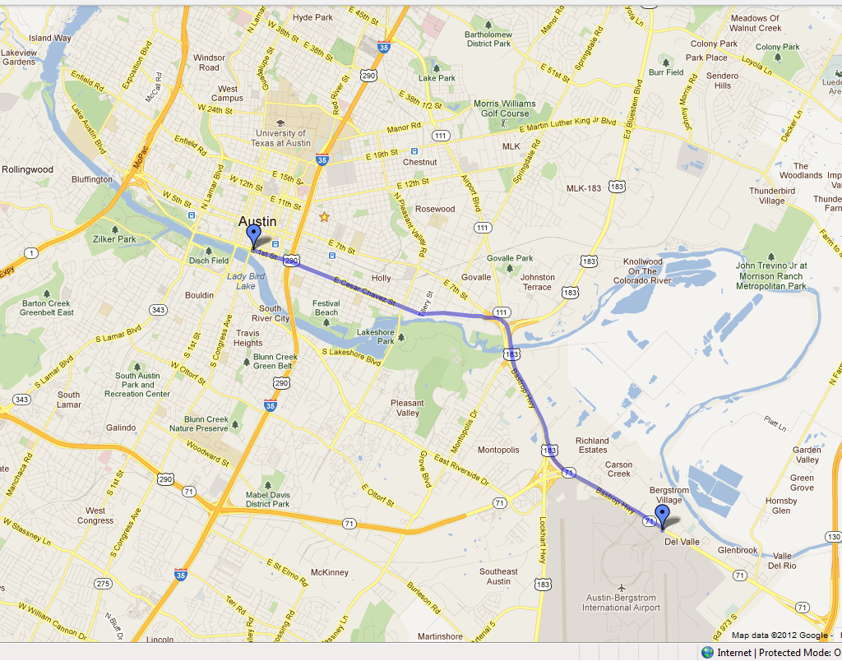
Reunion Activities
TENTATIVE LIST OF ACTIVITES AND INFORMATION

Gathering Room
Throughout the Reunion Weekend, we will have a suite with board games, mementos, old family photos, playing cards, beverages, snacks, etc. Please bring photos and other memorabilia to share with other family members.

Contribute to Photo DVD
Please email any family photos or photos from past reunions that you would like included in a digital photo DVD. We will also create a slide show for the Saturday evening event. For each photo please provide the following information:

- Date of Photo
- Name and Age of each person shown (if known) OR a brief description
- If the person is deceased please state so and provide the year (may create a special memorial tribute slide show)
Email photos to darius@austin.rr.com . Please separate your photos into manageable chunks before sending.

Saturday Morning To Afternoon
You will have all of Saturday morning and afternoon to explore Austin and rekindle relationships. The list of recommended activities can be found under the Things To Do In Austin section. A sign-up sheet will be provided for popular sites for ride sharing and companionship. Note that many attractions are within walking distance.

Saturday Evening Event
Location
The evening BBQ and family celebration will take place at the Zilker Park Clubhouse. This venue features one of the best views available of the Austin Skyline. While the Clubhouse is located only 2.5 miles from the reunion hotel, a MAP (safe to open) is required to find it if you are not familiar with the area.

Barbecue
Yes, and plenty of it…
A dinner of smoked meats and sides will be provided by Austin Barbecue Company – a catering business owned and operated by David Terrell. Be prepared to fight strong desires to relocate your family to Austin after experiencing brother David’s prepared feast!

Celebrating with Memories

During Saturday’s event we will take time to honor and remember beloved family members we have lost recently. If you have someone that you would like to speak for during this event you will have the opportunity to sign-up at the Friday Meet & Greet. Speaking time will be allocated accordingly. Please prepare your words in advance. Bring pictures!

We will take a group picture with the Austin Skyline in the background. We will also take generational pictures of each family for the members present (great grandchildren, grandchildren, children, siblings, parents, grandparents, great grandparents) organized by row. A link to download the pictures will be emailed after the reunion to everyone registered. Please make sure you are included on the list!

Music & Entertainment
Other than some fun activities designed to acquaint family members with each other we plan to have a sound system available that can play music from connected iPhones. Dancing is optional.

We are also looking into renting a Karaoke system. If you have a voice (or think you do) or want to form a group please indicate so on the registration form.

2012 Family Reunion Registration Information
Download Registration Form

You can download the registration form by selecting the link above (hold the Ctrl key), checking the box for the form, and selecting Download from the right-hand side. Note that this information packet is available from the site as well.

Please complete the entire form and return it with a check or
Money Order Payable to: Darius Terrell

Deadline to Register is: June 15, 2012
Mail to:
Terrell Family Reunion
c/o: Darius Terrell
11313 Aden Court
Austin TX 78739
Note that the registration form itself may be emailed to darius@austin.rr.com; however, the payment must be mailed to the address above.
Please distribute the information packet and registration form to family members that we may have missed.
Thank you,
Darius & Ann Terrell

Things To Do In Austin
Attractions of all kinds can be found in Austin and the downtown area! You can catch some great live performances or dance the night away on 6th Street or the nearby Warehouse District.
Listed are just some of suggestions. If you have questions, please do not hesitate to contact us.
For Food…
Austin has more restaurants per capita than most cities. The following are within a mile of our hotel:
If you’re looking for Tex-Mex, try:
Guero’s , 1412 Congress Ave
Chuys , 1728 Barton Springs Rd
El Mercado , 1302 South 1st Street
Torchy’s Tacos , 1311 South 1st Street
Manuel’s , 310 Congress (within walking distance of hotel)
If you’re looking for Sushi, try:
Bar Chi , 206 Colorado St (within walking distance of hotel)
If you’re looking for local fare, try:
Taverna , 258 W. 2nd Street, (Try the pizza) (within walking distance of hotel)
Shady Grove , 1624 Barton Springs Rd
P. Terry’s Burger Stand, 404 S. Lamar Blvd
For Museums
- LBJ Library , 2313 Red River (1.8 miles)
Located on the University of Texas campus in Austin.
- Texas Memorial Museum, 2400 Trinity St (1.7 miles)
Learn the history behind the great state of Texas.
- The Bob Bullock Museum, 1800 N. Congress Avenue (North of the Capitol)
Sightseeing….
SegCity and Duck Tours
Texas State Capitol
Parks
Zilker Metropolitan Park , 2110 Barton Springs Rd (spring water swimming, canoeing zilker-boating, Zephyr Miniature Train Ride, Botanical Garden, Hike and Bike Trail)
Lady Bird Johnson Wildflower Center
Hike around Town Lake
Want some fresh air? The Austin Hike and Bike Trail is just outside the rear of the hotel. I would suggest beginning your walk toward the Congress Ave Bridge. You will also have the real option of walking off the Saturday BBQ by taking this trail back to the hotel.

Other Local Austin attractions within walking distance from Town Lake:
- 2nd Street District, offering boutique shopping and restaurants
- Austin Children's Museum
- Austin Convention Center
- Austin's first-class entertainment, restaurants and festive nightlife available on 6th Street and the trendy Warehouse District
- Central Business District
- Congress Street Bridge, the hot spot for the world famous Austin Bats (watch their flight each night, weather permitting from Apr-Sep)
- Texas State Capitol
- Texas State Governor's Mansion

